Water Utility Problem Narrative

This document presents requirements for a customer database for a municipal water utility. You can assume that this description is the result of an initial investigation with appropriate personnel at the water utility. After the initial description, the guidelines presented in module 8 are used to analyze the narrative description and develop an ERD.

Information Requirements
The water utility database supports recording of water usage and billing for water consumption. To support these functions, the database should contain data about customers, rates, water usage, and bills. Other functions such as payment processing and customer service are omitted from this description for brevity. The following list describes the data requirements in more detail.
- Customer data include a unique customer number, a name, a billing address, a type (commercial or residential), an applicable rate, and a collection (one or more) of meters.
- Meter data include a unique meter number, an address, a size, and a model. The meter number is engraved on the meter before it is placed in service. A meter is associated with one customer at a time.
- An employee periodically reads each meter on a scheduled date. When a meter is read, a meter-reading document is created containing a unique meter reading number, an employee number, a meter number, a timestamp (includes date and time), and a consumption level. When a meter is first placed in service, there are no associated readings for it.
- A rate includes a unique rate number, a description, a fixed dollar amount, a consumption threshold, and a variable amount (dollars per cubic foot). Consumption up to the threshold is billed at the fixed amount. Consumption greater than the threshold is billed at the variable amount. Customers are assigned rates using a number of factors such as customer type, address, and adjustment factors. Many customers can be assigned the same rate. Rates are typically proposed months before approved and associated with customers.
- Water utility bills are based on customers’ most recent meter readings and applicable rates. A bill consists of a heading part and a list of detail lines. The heading part contains a unique bill number, a customer number, a preparation date, a payment due date, and a date range for the consumption period. Each detail line contains a meter number, a water consumption level, and an amount. The water consumption level is computed by subtracting the consumption levels in the two most recent meter readings. The amount is computed by multiplying the consumption level by the customer’s rate.

Identifying Entity Types and Primary Keys
Prominent nouns in the narrative are customer, meter, bill, reading (for meter reading), and rate. For each of these nouns, the narrative describes associated attributes. Figure 1 shows a preliminary ERD with entity types for nouns and associated attributes. Note that collections of things are not attributes. For example, the fact that a customer has a collection of meters will be shown as a relationship, rather than as an attribute of the Customer entity type. In addition, references between these entity types will be shown as relationships rather than as attributes. For example, the fact that a reading contains a meter number will be recorded as a relationship.
The narrative specifically mentions uniqueness of customer number, meter number, reading number, bill number, and rate number. The bill number, reading number, and meter number seem stable and single purpose as they are imprinted on physical objects. Additional investigation should be conducted to determine if customer number and rate number are stable and single purpose. Since the narrative does not describe additional uses of these attributes, the initial assumption in the ERD is that these attributes are suitable as primary keys.
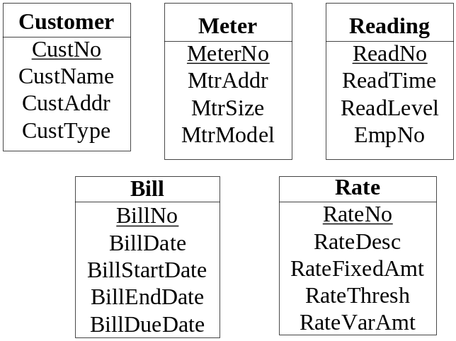
Figure 1: Preliminary Entity Types and Attributes in the Water Utility Database

Adding Relationships
After identifying entity types and attributes, let us continue by connecting entity types with relationships as shown in Figure 2. To reduce the size of the ERD, only the primary keys are shown in Figure 2. The following list explains the derivation of relationships with a focus on parts of the narrative that indicate relationships among entity types.
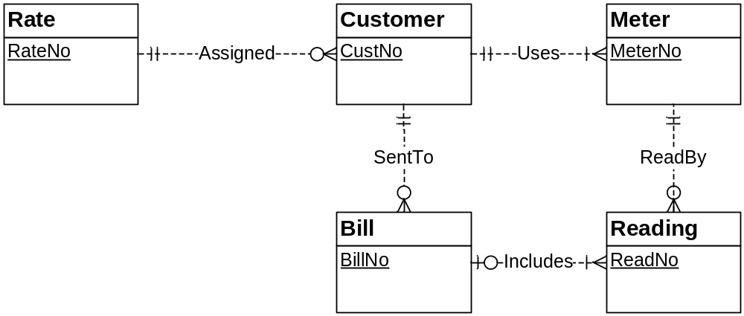
Figure 6.2: Entity Types Connected by Relationships
- For the Assigned relationship, the narrative states that a customer has a rate, and many customers can be assigned the same rate. These two statements indicate a 1-M relationship from Rate to Customer. For the minimum cardinalities, the narrative indicates that a rate is required for a customer, and that rates are proposed before being associated with customers.
- For the Uses relationship, the narrative states that a customer includes a collection of meters and a meter is associated with one customer at a time. These two statements indicate a 1-M relationship from Customer to Meter. For the minimum cardinalities, the narrative indicates that a customer must have at least one meter. The narrative does not indicate the minimum cardinality for a meter so either 0 or 1 can be chosen. The documentation should note this incompleteness in the specifications.
- For the ReadBy relationship, the narrative states that a meter reading contains a meter number, and meters are periodically read. These two statements indicate a 1-M relationship from Meter to Reading. For the minimum cardinalities, the narrative indicates that a meter is required for a reading, and a new meter does not have any associated readings.
- For the SentTo relationship, the narrative indicates that the heading part of a bill contains a customer number and bills are periodically sent to customers. These two statements indicate a 1-M relationship from Customer to Bill. For the minimum cardinalities, the narrative indicates that a customer is required for a bill, and a customer does not have an associated bill until the customer’s meters are read.
The Includes relationship between the Bill and the Reading entity types is subtle. The Includes relationship is 1-M because a bill may involve a collection of readings (one on each detail line), and a reading relates to one bill. The consumption level and the amount on a detail line are calculated values. The Includes relationship connects a bill to its most recent meter readings, thus supporting the consumption and the amount calculations. These values can be stored if it is more efficient to store them rather than compute them when needed. If the values are stored, attributes can be added to the Includes relationship or the Reading entity type.

